NAME: _______________________________________ DATE: __________________________________________

EXPERIMENT 37b

PROJECTILE MOTION
--------------------------------------------------------------------------------------------------------
Projectile Motion refers to the motion of an object in free-fall after it has been projected into the air. Galileo was first to show that projectile motion could be understood by analyzing the horizontal and vertical components of the motion separately. Since air resistance can be ignored, the horizontal component of motion is constant. Due to the acceleration of gravity, the vertical component of motion continually increases downward until the object reaches the ground. As a result, an object projected horizontally will hit the ground at the same time as an object dropped from the same vertical height. The flight path of the projectile is parabolic. Since there are no horizontal forces (wind resistance is being ignored), if the initial angle of the projectile is greater than zero the flight is a parabola which is symmetrical about a vertical line drawn through the apogee of the flight at the mid-point of the horizontal distance traveled.

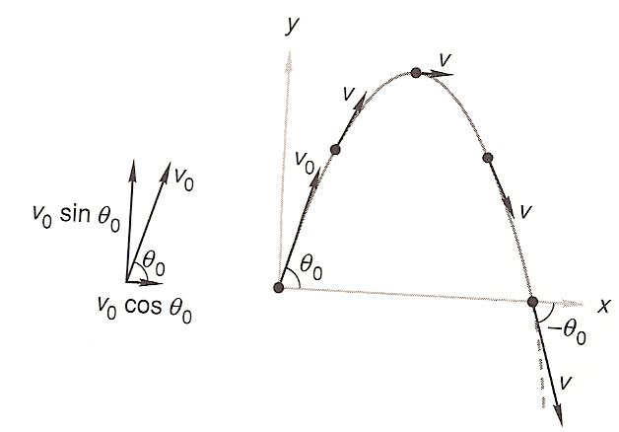
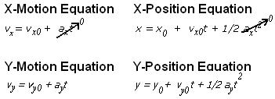

Various Forms of Equations Useful for Projectile Motion Problems

v₂ - v_{m} d sin Ø
t = -------- , v₂ = 0 (@ apogee), v_{y} = v_{m}sin Ø, a= -9.81 m/sec², t_{h} = ------------ , t_{v} = v_{m} --------- , t_{h} = 2t_{v}
d V_{m} cos Ø a

v₂² - v_{m}²
H = ---------- ,
2a
Where:
x₀ = Initial horizontal position of projectile (usually=0), y₀ = Initial vertical position of projectile (usually=0)
v₀ = v_{m} = Initial Velocity (muzzle velocity), v_{x0} = Horizontal component of initial (muzzle) velocity
v_{y0} = Vertical component of initial (muzzle) velocity
t = time, t_{h} = t_{x} = total flight time (horizontal time), t_{v} = t_{y} = time to reach apogee = ½ total flight time
Ø = Angle to horizontal in which cannon is fired
a = Acceleration, a_{y} = a_{v} = - 9.81m/sec² , a_{x} = a_{h} = 0
H = y_{max} (Maximum Vertical Height Obtained)

Objective
To determine the muzzle velocity of and height obtained by a projectile (tennis ball) launched at particular angle from the distance it travels and the flight time. Other aspects of the relationship between kinetic energy and combustion chamber pressure to the muzzle velocity will also be investigated.

Equipment
Tennis Ball Launcher (Potato Cannon) Tennis Balls (potatoes)
Propellant (propane, hair spray, etc.) Stop Watch
Distance Measuring Device (long tape, measuring wheel, etc.) Landing Markers (Bean Bags, etc.)

Procedure
Initial Preparation
1. Set up launcher at a convenient location which will allow for the estimated 100 yard (90+ meter) projectile
flight (e.g. back of end zone line on a football field).
2. Determine team member responsibilities. It works best to have at least four team members.
a. Team member 1 : Fuels and ignites launcher
b. Team member 2 : Loads projectile, assists in fueling, reads pressure gauge
c. Team member 3 : Times flight duration, assists in distance measuring, records data
d. Team member 4 : Field spotter, marks and helps measure distance that the projectile travels
e. Team member 5 : Use radar gun to shoot muzzle velocity as projectile leaves the barrel (opt.)

Member 1 Responsibilities: _______________________________________________

Member 2 Responsibilities: _______________________________________________

Member 3 Responsibilities: _______________________________________________

Member 4 Responsibilities: _______________________________________________

Member 5 Responsibilities: _______________________________________________

Other Support Members : _______________________________________________

_______________________________________________

Launch Procedure & Data Collection
3. Connect or verify that the igniter wires are all connected properly. See illustration shown below.

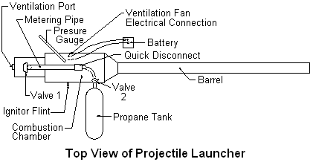

4. Put projectile (tennis ball) down cannon barrel and position with ram rod.
5. Attach valve 2 (make sure the valve is closed - tight clockwise) with flexible line to fuel bottle.
Connect flexible line “quick disconnect” to launcher.
6. Make sure valve 1 is closed (as shown, lever is 90º to metering pipe).
7. Battery leads to mixing/ventilation fan connection point, observing polarity.
8. Slowly open valve 2 (turn counter-clockwise), wait a few seconds for the pressure to equalize (you no longer
hear “swooshing” sound).
9. Close valve 2 (turn clockwise until it stops).
10. Open valve 1 (lever “in line” with metering pipe) and wait a few seconds for the pressure to equalize
(until you no longer hear “swooshing” sound).
11. Disconnect fuel bottle from launcher at “quick disconnect”.
12. Let mixing/ventilation fan run about one minute, then close valve 1. Disconnect ventilation/mixing fan
electrical connection(s). Make sure your lab partners are ready and in position for the launch. Especially
the team members manning the radar gun and timing the flight.
13. Quickly rotate the igniter flint. If the cannon does not fire, reconnect the fan electrical terminals and let it
run another minute or so. Quickly rotate the igniter flint again. If it still does not fire, remove the
ventilation port cover for a few seconds while the fan runs, reinstall the port cover, disconnect the fan
electrical connections and again rotate the igniter flint. Repeat the item 13 steps as necessary until a
successful ignition occurs.
14. Record the data, that is the maximum pressure shown on the gauge, the duration of the flight from the
combustion (loud “Whump”) until the ball (potato) first hits the ground, and the distance from the tip of the
barrel to the first point of contact with the ground (and optionally the radar gun reading) .
15. VERY IMPORTANT - You must make sure there is fresh air in the combustion chamber prior to the next
launch. The air in the chamber after the launch will be oxygen deficient, making the next launch less strong
or none existent if the air is not replaced. This is done by opening the ventilation port quickly after the
launch and reconnection the electrical power to the fan for several minutes (while getting DATA readings).
16. Repeat steps 4-15 three more times, or until you have at least 3 projectile flights with comparable data.

Data Recording Table

Launch Angle = _______ Projectile Mass = _______ Barrel Length = _______ Barrel Dia =_______
Launch No. | Flight Duration  (seconds) | Flight Distance  (feet or meters) | Pressure Reading  (psi) | Radar Gun Reading (Opt.)
1
2
3
4
5 (opt.)
*Average
* Do not include any values that differ greatly from the other values in the column in the average.

Computed Results
1. Muzzle Velocity from the Flight Duration
Combining and rearranging some of the equations on page 1 of these lab directions yields the following formula:
t (a_{y})
Vm = - ----------- , Where: Vm = Muzzle Velocity (V₀)
2 sin Ø t = Duration of Projectile Flight in Seconds
a_{y} = Vertical Acceleration (-9.8 m/sec²)
Ø = Firing Angle to Horizontal

Use the average flight duration value to compute the estimated muzzle velocity.

2. Muzzle Velocity from the Horizontal Flight Distance
Combining and rearranging some of the equations on page 1 of these lab directions yields the following formula:

d (a_{y})
Vm = ( - ---------------------- ) ^{1/2} , Where: Vm = Muzzle Velocity (V₀)
2(Sin Ø)(Cos Ø) d = Horizontal Flight Distance in Meters
a_{y} = Vertical Acceleration (-9.8 m/sec²)
Ø = Firing Angle to Horizontal

Use the average horizontal flight distance value to compute the estimated muzzle velocity.

3. Muzzle Velocity from the Combustion Pressure
Based upon the fact that the net work done on an object equals the change in kinetic energy of the object, the muzzle velocity should be able to be determined from the combustion chamber pressure, if the barrel is short enough that the projectile exits before the combustion is complete. This results in the following statement:

KE = Net Work => ½ mv² = F x D, Where: m = mass of projectile
v = muzzle velocity of projectile
F = Force (pressure x cross-section area of barrel)
D = Distance the projectile travels up barrel

Re-arranging the equation to solve for the muzzle velocity yields:

2g (P_{g} -P_{atm}) A_{p} D
v_{m} = (------------------------ )^{1/2}, Where: P_{g} = Pressure Gauge (psi)
w P_{atm} = Atmospheric Pressure (psi)
A_{p} = Cross-section area of projectile/barrel (pi r²)
w = Weight of projectile
g = Acceleration due to gravity

Because the gauge reads in pounds per square inch, values for acceleration due to gravity, weight, area, etc. will be entered in USA units and the result converted to metric units after computation. The numeric value of pi (3.14159) will also be used. Now the formula is:

(209.319) (P_{g} - P_{atm}) r_{p}² D
v_{m} =(---------------------------------)^{1/2} , Where: r_{p} = Radius of projectile (inches)
w w = Weight of projectile (pounds)
D = Length projectile travels up barrel (feet)

Using a standard tennis ball for a projectile and 14.7 psi for atmospheric pressure yields:

V_{m} = [2514.639 D (p_{g} - 14.7)] ^{½} x (0.3048 meters/feet)

Use the average chamber pressure value to compute the estimated muzzle velocity.

4. Another interesting item to determine is the height that the projectile traveled.
Combining and rearranging some of the equations on page 1 of these lab directions yields the following formula:

H = (v_{m} sin Ø)(t/2) - ½ g(t/2)² or H = - (v_{m} sin Ø)² / 2 g, Where v_{m} = Muzzle Velocity
t = Horizontal Flight Duration
g = Acceleration of gravity (-9.81)
Ø = Firing Angle to Horizontal

Determine the maximum height that the projectiles reached by using the average muzzle velocity & time values.

Result Analysis
1. Calculate the percentage differences between the various ways the muzzle velocity was obtained. What are the sources of error for the various methods. Which method do you think is most accurate and why?

_______________________________________________________________________________________________

_______________________________________________________________________________________________

_______________________________________________________________________________________________

_______________________________________________________________________________________________

2. What effect do you think air resistance played on the trajectory of the projectile?

_______________________________________________________________________________________________

_______________________________________________________________________________________________

_______________________________________________________________________________________________

_______________________________________________________________________________________________

3. If one wanted to maximize the horizontal distance, to what angle should the launcher be set? (support your answer with calculations).

_______________________________________________________________________________________________

_______________________________________________________________________________________________
4. Can you think of at least one more way that the muzzle velocity could be determined? (Hint, some of your homework problems may suggest a way using an additional piece of easily constructed equipment. Two other possible ways come to the mind of the author of this lab direction set).

_________________________________________________________________________________________________

_________________________________________________________________________________________________

_________________________________________________________________________________________________

_________________________________________________________________________________________________

